Environmental Policy
Revision 10 – October 2025

Vision Constructions Qld is committed to pollution prevention, environmental protection and minimising all environmental impacts associated with our operations, in keeping with compliance and regulatory requirements. Furthermore, we are committed to the continual improvement of our Environmental Management System and its results.
Our key points to achieve this are:
- We will ensure our activities are conducted in accordance with this policy and current environmental legislation requirements.
- We will adopt the reuse, recycle principles to minimise environmental impact.
- Train and inform all staff and subcontractors on current environmental procedures so they can respond in a timely manner.
- Have suitable and well maintain equipment on site.
- Identify and prevent pollution at its source.
- Consider the potential impacts of climate change in our planning and operations to enhance resilience and long-term sustainability.
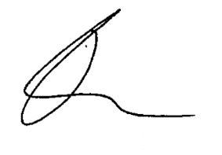

Travis Maher
Managing Director

Date: 22 October 2025

